Latest News
BFTA Champions and Inter-Regional Competitions
Wales building on their success at the World Field Championships last year in Lithuania in becoming World PCP champions, achieved another major success in winning the BFTA Inter-Regional championships. This is the first time that Wales have ever won this event and we congratulate the team on their great performance
Tondu hosted these competitions on the 2nd and 3rd of April. Creating two separate courses one for each event. Competitors had to contend with rain, sunshine, gusty wind and mud, but despite these conditions competitors found these courses quite challenging and well designed and Tondu received many positive comments from competitors. Many thanks to Tondu for their efforts in hosting a very successful event.
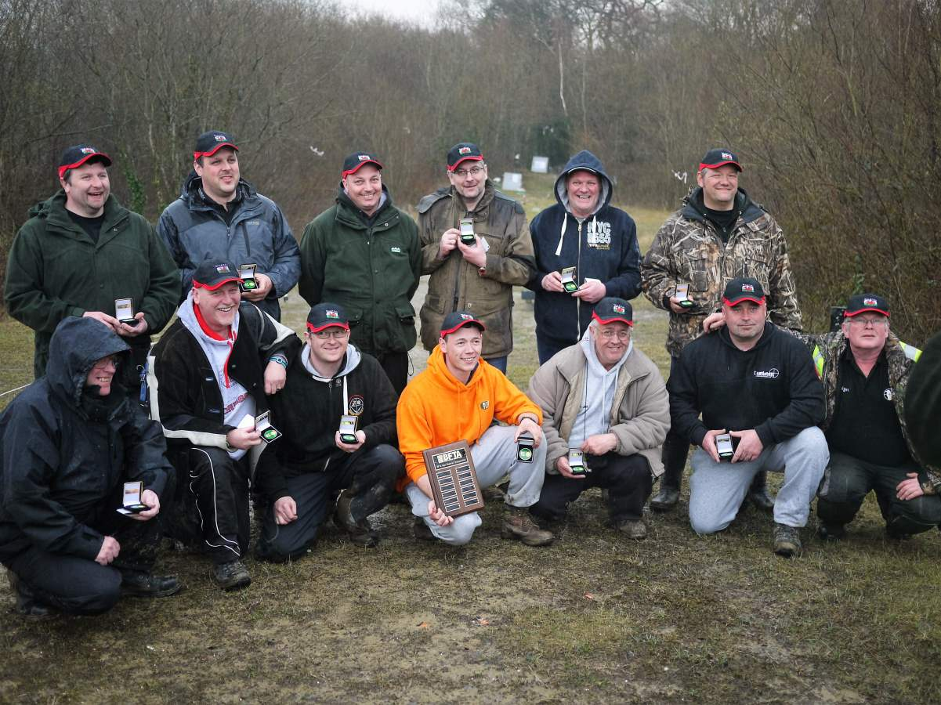 Welsh Team -2016 BFTA Regional Champions

Results
Inter-Regional's
Position | Region | Points
1 | WAFTA | 288
2 | CSFTA | 284
3 | MFTA | 283
4 | NEFTA | 279
5 | SEFTA | 274
6 | SWEFTA | 253
7 | FFTA | 241
8 | NWFTA | 178

BFTA Championship
1st Wood Justin 37 ,2nd Higgins Simon 36 ,3rd Schofield Dave 35 ,4th Harris Jack 34, 5th Tomes Darren 34 ,6th Jerram Ian 34, 7th Fekete-Moro Andras 34, 8th Corbett Craig 33, 9th Willingham Jon 33, 10th Phillips Ian 33
J