Wales 2017 – Newsletter 3 –February 2017
It has been some time since we updated you on our progress on the preparations for Wales 2017. We have made good progress since Lisbon 2016 and are on schedule to meet our key deadlines. The primary areas that we have been working on are:
Registration
Sergio, you were correct in saying that registration is a nightmare – we did not believe you!
Richard Beaugie and I have spent the past 5 months working on this huge and complex task , having overcome the initial PayPal problems and changing the payment system to Bank transfer, RGB’s sucessfully registered their Teams at the end of October. We then opened registration to individual competitors – we did not expect that we would have 151 registrations in three hours – this was evening that I will never forget!
Since registration opened we have been communicating with and resolving competitor’s issues with registration, and answering queries on a daily basis.
Registration Current Status:
- All Individual Competitors have completed registration, except for a few from the reserve list who have recently been invited – Alan Otsuka you will be pleased to hear is one of these.
- The following RGB’s have fully completed registration of all the members of their teams: England, Hungary, The Netherlands,New Zealand, Norway, Portugal, Scotland, Turkey and Venezula,
- The following have part completed the registration of team members: Canada, Chile, Estonia, Germany, Greece, N.Ireland, USA, Uraguay and Wales.
- The following RGB Teams have yet to start the selection and registration of their Team members: Argentina, Bulgaria, France, Italy, Poland, S.Africa and Spain (Team to be selected from Individual registrants).
- The reserve list currently has 14 potential competitors waiting to be offered a place if some competitors drop out or Teams do not fill all their reserved places. We have to date successfully allocated 44 places to those on the reserve list.
- All 375 places are currently filled with fully registered individual shooters,Team members and reserved,unregistered Team members.
- 28 RGB’s will be represented at Wales 2017
- Wales 2017 will be largest FT competition in the history of our sport.
Registration Deadline
We need to fully complete registration by the 1st of May and would encourage those RGB’s who have not started selection and registration of their competitors to do so as soon as possible.
Team members can of course be changed by substituton with individual, registered competititors beyond this date and up until the 20th of September (as per the core rules on naming Teams). However we need to have all competititors registered by the 1st of May, as we need to order the personalised Polo shirts which have a long lead time, and to finalise the catering arrangements for the Welcome and Awards Dinners.
Catering and Welcome and Awards Dinners

Onsite Catering at Glanusk
We will in the near future be selecting 2-3 catering companies to supply hot and cold food, and drinks on site at Glanusk from the Tuesday until the Saturday. We will have these facilities available from 7.30am until 6.30pm each day.
Bottled Water
We have decided that we will not be supplying disposable, individual bottles of water to Competitors, as this will create issues for our marshalls with distribution, and the disposal/collection of empty bottles Instead each competitor will receive a reusable water bottle in their welcome pack – courtesy of AIR ARMS . These can be refilled from bulk water stations situated around the course.
Welcome and Awards Dinners
Given the number of competitors, guests and Sponsors requiring dinners we will have different formats for each dinner:
Welcome dinner: this will take place in the main building of the Manor Hotel as the numbers attending will be significantly lower that the Awards Dinner and these numbers can be accomodated.
Awards Dinner: as we expect to cater for 500+ this number will exceed the capacity of Manor Hotels’ function rooms. So a marquee will be situated in the hotel grounds to accommodate everybody. This will have sound and projection equiptment. In addition we will have the use of all the Hotels facitities during and after the awards dinner and presentations.
Marshalling Courses

We are giving a high priority to ensuring that we have sufficent WFTF trained Marshalls for Wales 2017, and that the number of trained Marshalls within RGB’s increases, so we will be running two courses prior to our event. Brian Sampson will be running both courses – thanks Brian for you support in this critical area.
The first course will be held at the Hafodyrynys Rugby Club (300m from Bleanau Gwents’ shooting ground) at 12noon on Saturday the 27th of May – the day before GP3 (the Welsh Open). This we hope will be attended by as many UK competitors as possible. Catering and refreshments will be provided and everyone who successfully completes the course will receive a WFTF Marshall badge.
The second course will be held at 12noon on Tuesday the 19th of September at the Manor Hotel. Nearer the date I will e-mail RGB’s to request an estimate of the numbers likley to attend. Food and refreshments will be provided for all those wishing to attend.
Welsh Weather Precautions
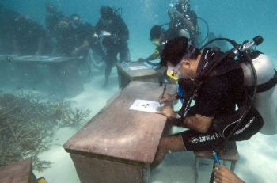
The weather in Wales is very unpredictable – we could experience an’Indian Summer’ and all be shooting in shorts or it may rain every day for the entire week. We cannot control this so we have given a great deal of thought as to how we can mitigate the impact of wet weather on the competition.
Score Sheets: we will be using waterproof and tearproof paper for the score cards – Xerox Nevertear. This paper has been tested, and you can write with a biro or pencil ( not fiber tipped pens) underwater on this paper.It is 20 times more expensive than normal card, but well worth the expense, to avoid the potential nightmare of 375 wet and disintegrating score cards. Score cards have already been printed in the WFTF format.
Timers: Portugal experienced a significant timer failure rate, probably caused by extreame temperature and strong light. We will potentially have different problems with timers, so for example if it rains, normal Kitchen Timers will fail, as they are not waterproof. So we have ordered waterproof timers to hopefully avoid this issue.
We would strongly advise competitors to pack waterproof clothing and footwear (as well as shorts and sunglasses) for Wales 2017, hopefully they will not be required, but it is best to be prepared.
Lane,Target and Positional Signage
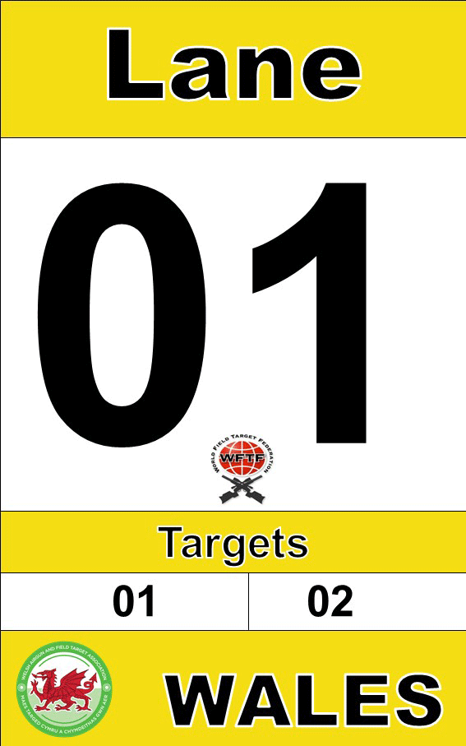
All the signage has been printed, but has yet to be laminated and applied to boards.
Trophies and Medals
We will be awarding medals to all classes in compliance with WFTC core rules. In addition we will be awarding medals to 1st,2nd and 3rd places for Juniors, Veterans, and Ladies .
All Champions of their classes will in addition to receiving a medal will be awarded a special, unique trophy designed for Wales 2017.
The design of medals and Trophies will reflect ‘the year of the dragon theme’. The final design has been agreed and they have all been ordered.
Sergio has kindly donated the WFTF sports award medal which he has redesigned to reflect Wales 2017.

Course Design and Layout
Our course design/building Team spent an entire day planning the position of the courses,lanes and target positions. So we have a very good idea at this stage of the final course design, and we hope that everyone finds it interesting and challanging. The 3 courses will not be integrated - dispensation for this has been agreed by RGB’s, instead the courses will follow one another i.e White course lane 25 will be followed by Black course lane 1.
The overall length of the combined courses is approx 2.5 Km.
We will be using White,Black and Yellow targets only .
Zero Range: the location of this has been agreed – it will be directly opposite the competitors car park ,and will be approx 200m long, so there should be no requirement to restrict the time that competitors can spend there.
Standing Sillouette Competition: this will be situated in the walled garden and there will be three separate, identical courses to avoid queues. Sponsors can also use this area to demonstrate their equiptment.
Registration and Equiptment Checks
The registration office will be located in (or outside if dry) Glanusk Lodge, and registration will open at 12 noon on the Tuesday and close at 4pm on the Wednesday.
Registration and Stats will be managed by Paula Higgins and Sam Reece.They both have considerable experience over may years with running Stats at all of the UK’s major competitions. Welcome to the Wales 2017 Team Paula and Sam, and many thanks for volunteering to undertake this most complex of tasks.
Paula and Sam will be supported by other volunteers , particulary during registration.
We will not permit Competitors to shoot on the zero range or the Sillouette courses without first registering, having their gun chronographed and all their equiptment checked for compliance to WFTF core rules. Marshalls will strictly enforce this rule.
Safety with Airguns at Glanusk
Glanusk is a busy estate which will have other activities and enterprises ongoing during our competition week. To respect the wishes of the owners of the estate uncoverd airguns will only be permitted on the courses,zero range and standing sillouettes. At all other times your gun must be unloaded and in a gun slip to travel to the ranges.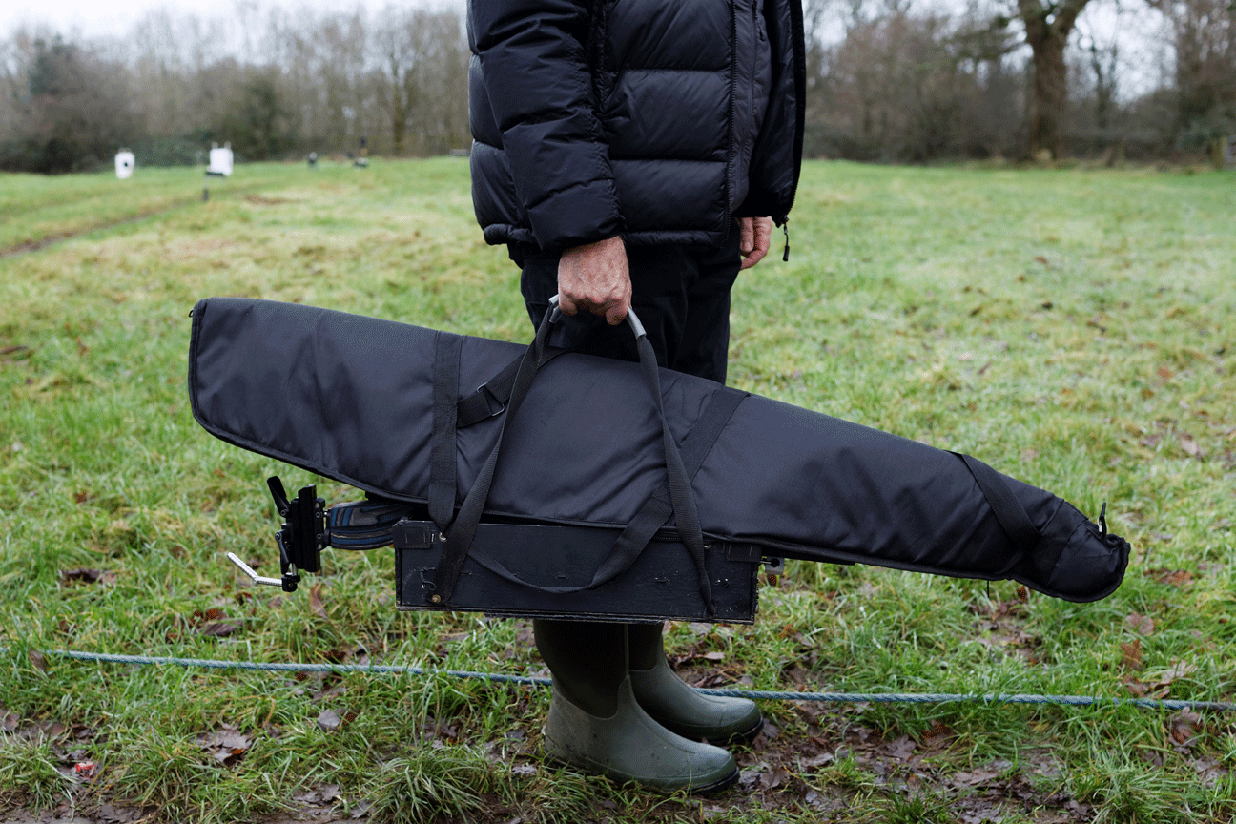
For those that prefer to use a caddy for their gun ,please cover as per the photo above.
Once you are on the ranges there will be no requirement to use a gun slip or cover.
Game Birds and wildlife: the estate breeds Pheasants for game shooting and releases over 9000 in August for shooting in the Autumn and Winter. Whilst most of these will be located away from our courses, however some will inevatably be found on the ranges. Birds, Squirrels and other wildlife will also be present on the ranges.
Shooting of Game Birds and wildlife at Glanusk will not be permitted under any circumstances and will be treated by Marshalls as a diciplinary offence.
Compressed Air Supply
We are grateful to Daystate who will be supplying two air compressors and a back up compressor. These will be used to refill the air bottles at our compressed air station located near the zero range.
British Field Target Association – European Competition
Those non UK Competitors who expressed an interest in attending this event, which will take place the weekend before Wales 2017 can get information about this event and register online by clicking the following link: http://www.thebfta.net/news/the-26th-bfta-european-championship-2017/
Communications and Media
Facebook: we currently have over 1,400 ‘friends’ on Facebook. This has proved to be an essential communication tool, particularly during registration.
To give more focus to Sponsors and general Worlds Airgun chat Daniel Harris has created another Face book page - WFTF World Championships Wales 2017 , this is linked to our original Facebook page, which will continue to serve as our communication tool. Please get involved with the new FB page, you are welcome to post photos, scores etc and to have fun leading up to the worlds. We would encourage all RGB members to tag the page when posting their own content and we will share it
Media:
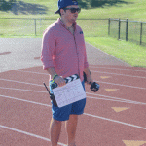 http://www.teamwild.tv
http://focusshiftfilms.com
Daniel Harris is now fully involved with our planning team and he will be recruiting four University Media Students to film our event. Daniel has teamed up with Team Wild TV, who will host videos of our event. Team Wild have over 100,000 subscribers – so we will reach a very large audience for our sport.
Welcome Pack: we will e-mail every competitor a welcome pack in August. This will detail all the essential information that you will require for Wales 2017. Included will be your official invitation letter to Wales 2017.

Sponsors
Mark Bassett has been working hard to bring Sponsors onboard for Wales 2017. The website will be updated soon to give more details of what Sponsors are contributing. If RGB’s are aware of potential Sponsors in their countries who wish to support Wales 2017, then please contact us at admin@wftc2017.wales . To date we have the following Confirmed Official Sponsors for Wales 2017:

