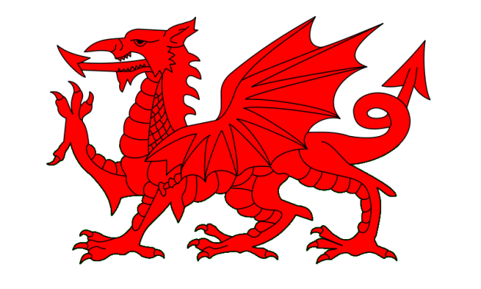
Maes Targed Cymru a Chymdeithas Gwn.Aer
Welsh Airgun and Field Target Association

WFTC Wales 2017 - The Year of the Dragon
Update on Progress towards WFTC 2017
Whilst RGB's are currently focused on Portugal 2016 - 'the year of the Cockerel ' the Welsh Airgun and Field Target Association WFTC planning committee has since September 2015 been busy planning and preparing for 'the year of the Dragon'.
We are now in a position to communicate some of the details and plans for WFTC Wales 2017
Croeso i Gymru - Welcome to Wales
Wales - never to be confused with England, is a country which is part of the United Kingdom and the island of Great Britain. It has a population of just over 3 million and has a total area of 20,779 km² (8,023 sq. mi). Wales has over 1,680 miles (2,700 km) of coastline and is largely mountainous, with its higher peaks in the north and central areas, including Snowdon, its highest summit. The country lies within the North Temperate Zone and has a changeable, maritime climate, so one can expect rain and wind.
Wales has its own elected parliament situated in the capital - Cardiff. Although Wales closely shares its political and social history with the rest of Great Britain, and the vast majority of the population speaks English, the country has retained a distinct cultural identity and is officially bilingual. Over 560,000 Welsh Language speakers live in Wales, and the language is spoken by a majority of the population in parts of the north and west.
See visitwales.com for more information on Wales.
WAFTA - The Welsh Airgun and Field Target Association
WAFTA are very honored and pleased to be hosting WFTC 2017. We hope that our plans and preparations will provide a unique Welsh FT experience.
WAFTA was founded in 1983 and can claim to be the old RGB in the world, (Scotland FTA was founded in 1984, England FTA 1990 and the USA in 1987). We have seven FT clubs located primarily in the south of Wales. The type of courses that we have in Wales are not heavily forested , unlike those in Europe , indeed some have very few trees - hence you will find 'Field' target rather than 'Forest' target competitions in Wales . Our event will reflect this heritage to some extent, and expect wind to be a major influence on performance. Rain is not uncommon, so be prepared with suitable clothing.
Welsh shooters have attended WFTC's since the inception of World FT, and had a very successful year last year in Lithuania, winning the PCP Team event and taking 4 of the top 10 PCP places and the Veteran class. We look forward to Portugal, however Wales 2017 remains our primary focus.
Event Location
We have selected the Glanusk Estate Park as the venue for our event. Glanusk is a privately owned estate and the park area of the estate where we will hold the competition covers 400 acres (160 hectares). Set in the Brecon Beacons National Park it is an area of outstanding natural beauty and is located near to Crickhowell a small market town with many individual shops, ancient inns and plenty for visitors to do. Surrounding Crickhowell are the picturesque villages of Llangattock, Llanbedr, Llangenny, Glangrwyney, Tretower and Cwmdu, each with their own special character.
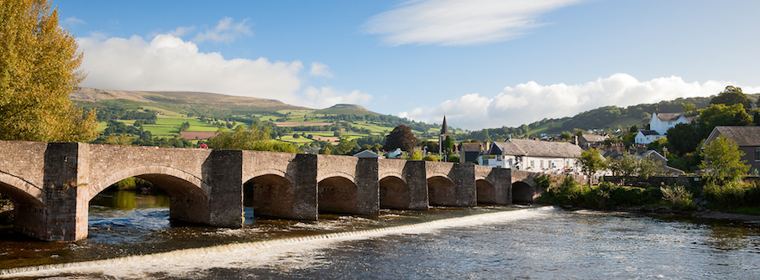
Crickhowell on the river USK

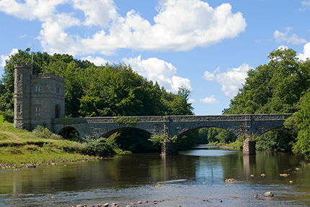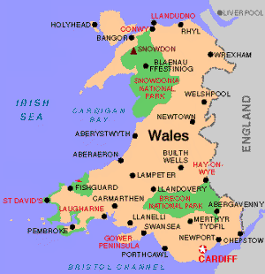
Glanusk Estate - Tower Bridge entrance to Shooting Ground
For more information on Glanusk visit: glanuskestate.com
For Crickhowell: visitcrickhowell.co.uk, on this website you will find information on local accommodation.
WFTC 2017 Program
We will be holding our event between the 19th and 23rd of September 2017
Tuesday - Registration and zero range open, welcome dinner
Wednesday - Registration and zero range
Thursday - Competition Day One
Friday - Competition Day Two
Saturday - Final Day of competition, Awards Ceremony

The Red Dragon
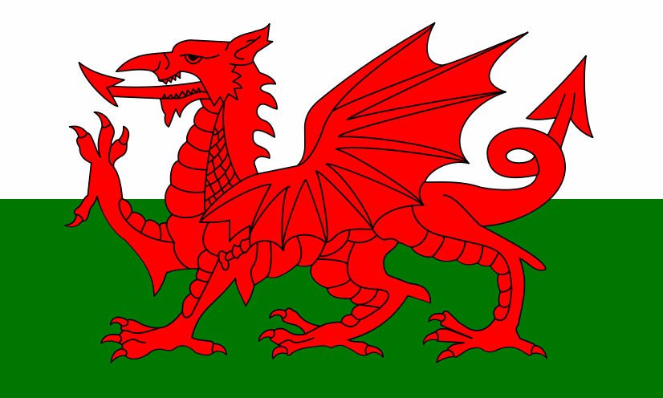
We have chosen the Welsh Red Dragon as our Logo for Wales 2017, it will be themed to appear on the WFTC 2017 website, trophies, all signage, documents, sweatshirts and badges.
The proud and ancient battle standard of the Welsh is The Red Dragon (Y Ddraig Goch) and consists of a red dragon, passant (standing with one foot raised), on a green and white background.
It is considered that the Welsh kings of Aberffraw first adopted the dragon in the early fifth century in order to symbolise their power and authority after the Romans withdrew from Britain. Later, around the seventh century, it became known as the Red Dragon of Cadwaladr, king of Gwynedd from 655 to 682. The red dragon itself has been associated with Wales for centuries, and as such, the flag is claimed to be the oldest national flag still in use.
Owain Glyndwr the last native Welshman to hold the title of Prince of Wales raised the dragon standard in 1400 as a symbol of revolt against the English Crown, he was however unsuccessful in his attempt to gain independence from the English. The dragon was brought to England by the House of Tudor the Welsh dynasty that held the English throne from 1485 to 1603. It signified their direct descent from one of the noble families of Wales. The green and white stripes of the flag were additions of Henry VII, the first Tudor king, representing the colours of his standard.
Welcome and Awards Dinners
For the welcome and awards dinners we have booked the Manor Hotel which is located only 1Km from Glanusk. This is an early 18th century Manor house which is situated high on the side of the Black mountains with stunning views over the Usk valley.
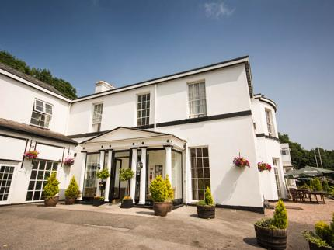
The Manor has 22 bedrooms and we are currently negotiating a discounted rate for competitors who wish to stay here, we will advise you at a later date on how to book rooms there.
Website: manorhotel.co.uk
Accommodation
There are no major motels in the vicinity of Crickhowell, however there is a wide range of small character full hotels, inns with rooms, bed and breakfast accommodation and a large number of holiday lets, close to Glanusk.
We are currently looking at discounted accommodation for Wales 2017, and will advise you of deals available in a future update.
Website
We have registered the domain name: wftc2017.wales . The website is currently under construction, and will be launched on the 22nd of August 2016
Registration for Wales 2017
The registration process for Teams and individual competitors will be opened on the website on the 2nd of September 2016.
We will introduce a different format for registration than has been used previously by World's host RGB’s. This is in order to manage the anticipated high demand for places at our event.
The UK has the largest number of FT shooters in the World and we expect (and are already receiving) significant interest in places for our event. So we need to ensure that we initially give priority to the registration of RGB Teams and then open the registration process to individual competitors. At BFTA Grand Prix competitions in the UK it is not unusual to have 150+ competitors attending, so given the large number of potential UK competitors for our event we are expecting attendance to exceed 300.
We will update you on our registration process and procedures in an update prior to our Website launch.

The Competition Course
We are planning to construct three courses that are integrated into one with alternating lanes for each course, as per WFTA core rules.
We are planning to have two sessions per day.
The zero range will be located in a the walled garden which has 3 meter high stone walls on all sides and covers an area that is 60x 70 meters.
Welsh Weather in September
Historically September is one of the driest months, with average temperatures during daylight of 18 c, so ideal for FT. We will have 12 hours of daylight at this time of year, so sufficient for our two session event.
TV Coverage
A local TV company has expressed an interest in covering our event.
Sponsors
We have already had significant interest from potential sponsors and to date have eight major sponsors on board.
Details of sponsorship will be included on our website.
BFTA European Competition
The British Field Target Association will be holding their annual European competition on the 16th and 17th of September 2017. This consists of two 50 target courses held at the Midland Game Fair, Weston Park, Shropshire, England.
See - midlandgamefair.co.uk for information on the 2016 event.
For those competitors that wish to enter this event and Wales 2017, they will have the unique opportunity to shoot 250 targets over 8 days.
We will update you at a later date on the registration process for the BFTA Euros.
Look out for another Update on Wales 2017 in May 2016.
At this stage we are unable to respond to queries on Wales 2017, as you will appreciate we are currently busy focusing on the planning of our event.

John Johnston March 2016

